
Lifecycle of a Stormwater Pond
Background:
When new impervious areas, like streets and sidewalks, are constructed, the water from a storm cannot infiltrate into the ground. The water that stays on the surface is called runoff and is collected in a series of inlets and pipes. These inlets and pipes convey the storm water to a stormwater pond. There are two types of stormwater ponds: a detention pond and a retention pond. A detention pond only holds water when it rains, while a retention pond has a permanent pool of water. The goal of a stormwater pond is to hold a certain volume of water and release it at a slower rate into the receiving streams. The slower release rate protects the downstream creek from having too much water. It also allows the sediment and trash from the surrounding area to be collected in the pond. The image below shows an example of an existing detention pond in Superior.
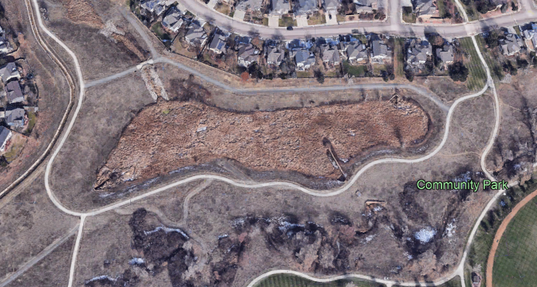
Figure 1: This is an aerial view from Google Maps of the Flor Pond. These ponds provide flood mitigation and water quality for the surrounding neighborhood.

Design and Construction:
A civil engineer designs the pond to store the volume of a certain storm. Typically, ponds hold the volume of the 100-year storm, or the amount of water from a storm that has a 1% chance of occurring during the year. This volume is based on historical rainfall data in the area as well as flood modeling. The plan specifies the elevations and slopes of the pond to ensure it is built to hold the desired volume. The outlet structure is placed at the lowest point of the pond and releases the storm water at the historic rate at which the water entered the stream prior to construction of impervious areas. See Figure 2 below for the Coalton St Pond civil plans. This ensures the stream is not overwhelmed with the additional volume of water. An overwhelmed stream can result in erosion along the banks or a larger floodplain, putting structures in danger of flooding.
When it is time for construction, the contractor will use excavators and front-end loaders to construct the pond at the elevations on the plans. They block the inlets and pipes along the streets to prevent water from entering an unfinished pond. Before the pond is vegetated, it is surveyed to ensure it can hold the specified volume. The engineer who designed the pond submits a pond verification letter stating it was built according to the plan and will hold the volume it needs to protect the surrounding and downstream structures.
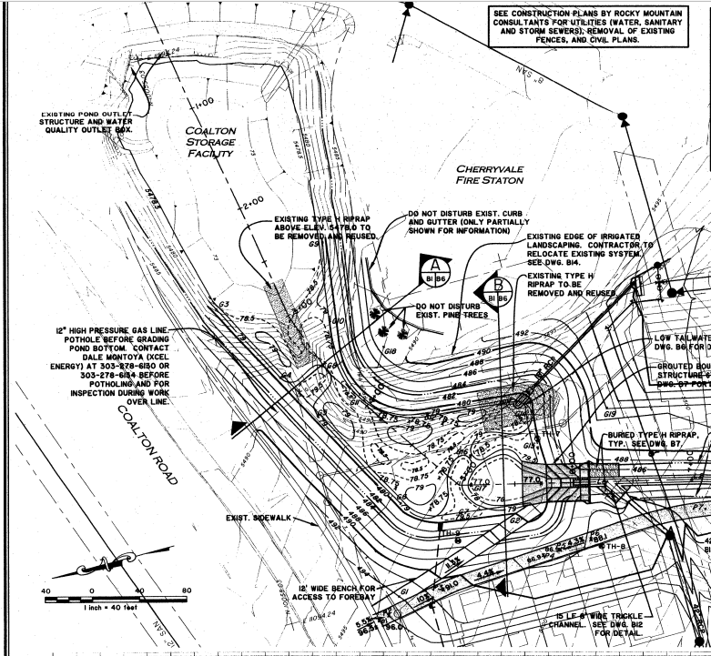
Figure 2: An example of civil construction plans for a stormwater pond. The lines on the plans are called contour lines and are labeled with an elevation. The contractor will build the pond at these elevations so it can hold the specified water volume.
Maintenance:
Once construction is complete, the inlets and the pipes become active and start sending storm runoff to the pond. The sediment, trash and debris from the local surroundings are also conveyed with the runoff. In addition to flood protection, the detention pond serves as a central location for collecting these items. This is helpful for maintenance crews to keep the neighborhoods and downstream water ways clean. Trash and debris removal occurs between two and three times a year if needed.
Over time, the entire pond fills with sediment and vegetation. At some point in the life of the pond, this material needs to be removed to bring it back to its original condition. This ensures the pond can maintain its function for flood control and water quality for the area that it serves. While all ponds are different, an 8-to-10-year maintenance cycle seems to work well. The sediment is removed and placed in a large pile called a stockpile to dry before being disposed. The drying process can be up to a few days depending on the weather and can result in some undesirable odor. See Figure 3 below. Once maintenance activities are completed, the disturbed ground is scraped to loosen the soil and seeded with native species. By the next growing season, the grasses are beginning to grow, and the pond is functioning as originally intended.
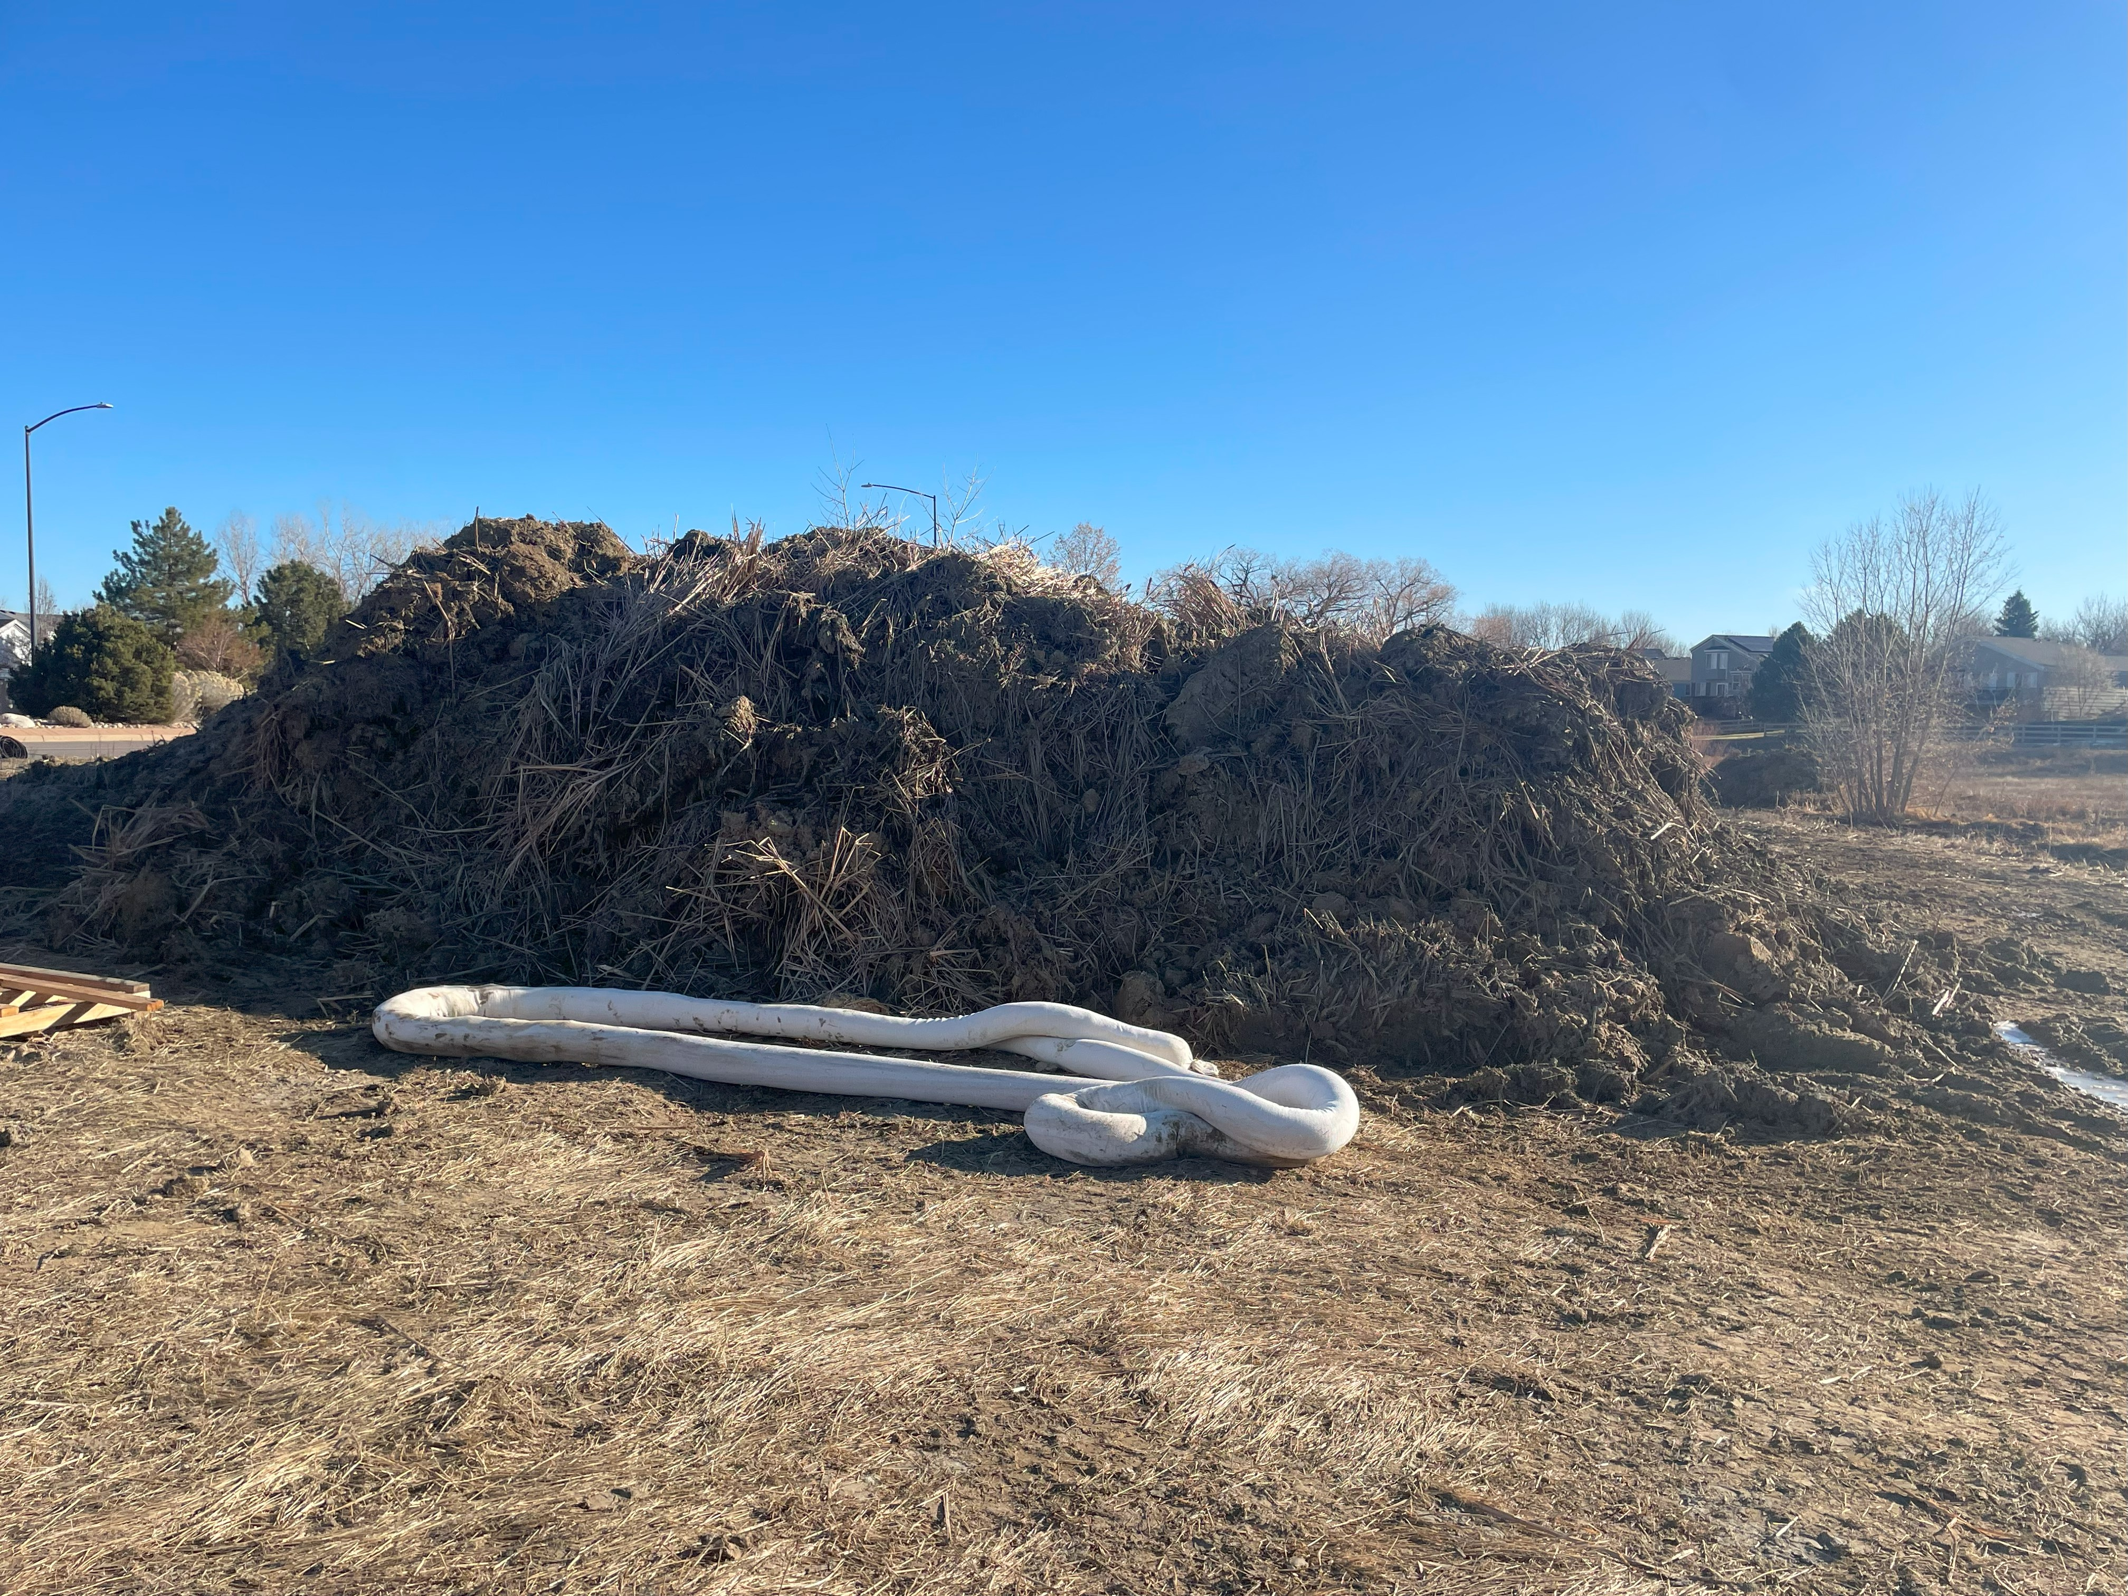
Figure 3: Here is an example of a stockpile of material removed from a detention pond. This pond had accumulated over 700 tons of material since its last maintenance efforts about 10 years ago.

